

Directions to UCF, Partnership I Building
(aka-National Center for Forensic Science)

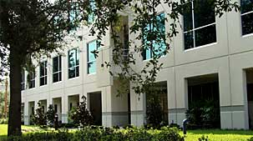
Use this address for the end address:
University of Central Florida
Partnership I Building
12354 Research Parkway
Orlando, Florida 32826

*Please be aware that during meetings sometimes our parking lot fills up. If this occurs please park in the Partnership II which is the new building on the corner of Research Parkway and Technology Parkway
Directions to UCF, Partnership I Building from the Orlando International Airport (OIA):
- Take Hwy 528 (Beeline toll) East to Hwy 417 (Greenway toll) towards Orlando
- Go North on 417 to Hwy 408 (East-West Expressway toll)
- Go East on 408 (Towards Titusville) to the end of the expressway (Challenger Drive)
- Turn Right at Alafaya Blvd (Hwy 434 North)
- Turn Right at Research Parkway (Bank of America on the corner)
- After the first traffic light (Technology Parkway) Turn into the first entrance on your right
- At that turn you will see a gray sign for the Naval Air Warfare Center
- Prior to the security gates take a left into the parking lot; UCF, Partnership I Building will be the three story building on your left
- After entering the building go to Conference Room 102
*Please be aware that during meetings sometimes our parking lot fills up. If this occurs please park in the Partnership II which is the new building on the corner of Research Parkway and Technology Parkway

